Stewardship Lessons for Timothy – Speakers Notes

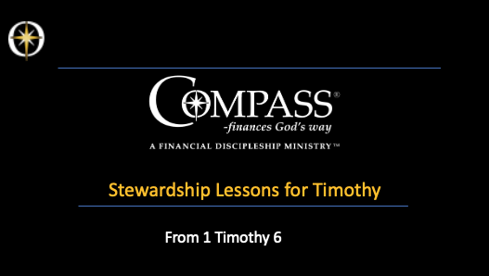

In his 1st letter to Timothy in chapter 6, he gave some all-encompassing, very important stewardship lessons. Paul knew that managing money Gd’s way was key to growing as a disciple.

Paul mentored Timothy by equipping him for the tasks of ministry, empowering him for success, employing him in the church in Ephesus.

These stewardship lessons were mean to equip Timothy as a financial disciple to combat false teaching in the church.

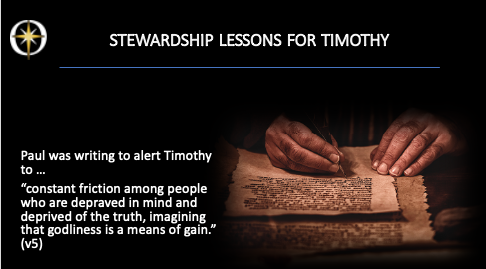

In this chapter, Paul was writing to warn Timothy against people who were in “constant friction among people who are depraved in mind and deprived of the truth, imagining that godliness is a means of gain.” (v5)

- They looked at spirituality as a tool for material success.
- False teachers were seeking to make a profit from their leadership role
- the false teachers saw spirituality as a business venture, or a money-making tool.

Paul had previously written in chapter 5, that teachers and pastors ought to be paid for their service to the church – but Paul warns about being focused on money for personal gain.
It is a strong warning against so-called ‘prosperity teaching’ - that sons and daughters of the King ought to be rich!

3

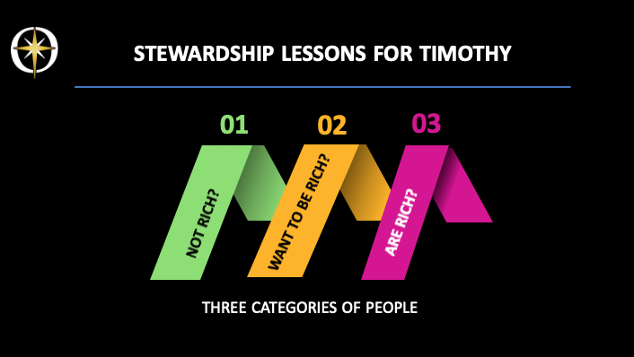

Pual’s lessons on stewardship were meant to help Timothy teach 3 kinds of people

- those who are not tich
- thos who want to be rich
- those who are rich

But the lessons are really valid for all three groups!

4

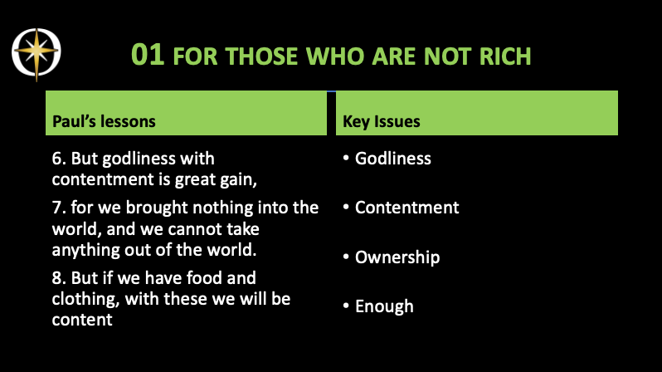

Let’s look at the first group of people – those who are not rich

6. But godliness with contentment is great gain,
7. for we brought nothing into the world, and we cannot take anything out of the world.
8. But if we have food and clothing, with these we will be content

- Godliness is demonstrating the reality and character of God in life. Allowing the Holy Spirit to reproduce the life of Christ in your own life.
- Contentment means to actively thank God for His provision, be satisfied with what you have, no matter what the circumstances.
  - God does not make mistakes
  - If you are not rich and have only enough to survive, suffering – if you allow God to use this – can be turned into character traits of Jesus.
- We brought nothing in and cannot take anything out … we only have the opportunity to use it for a certain time.
  - We do not really own anything.
  - So why do we act as if we do, and hold on tight to our possessions?
- Food and clothing? Can we be content with the basic necessities for survival?
  - Can we learn to live on less, so that if we have more than the basic necessities, we can freely share with others?

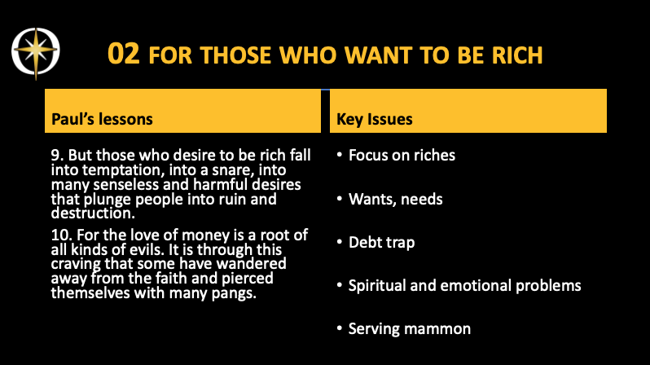

9. But those who desire to be rich fall into temptation, into a snare, into many senseless and harmful desires that plunge people into ruin and destruction.
10. For the love of money is a root of all kinds of evils. It is through this craving that some have wandered away from the faith and pierced themselves with many pangs.

- These people have a strong focus on getting rich: and this is dangerous because it opens a door for mammon and its temptations
  - Senseless and harmful desires
  - A trap – in which we get deeper and deeper into devotion for money
- Ruin and destruction
  - Maybe through illegal or dishonest dealings
  - Cheating on taxes or expenses
  - Lying to get our own way – or manipulation people
- A debt trap …
  - Debt is mammon’s banana skin …
  - If you become over-indebted and cannot pay what is due – you loes your freedom
  - The creditor has power of you and has first call on your money – God should have first call
- Love of money
  - No one can serve two masters, for either he will hate the one and love the other, or he will be devoted to the one and despise the other. You cannot serve God and money.
  - Love for money is at the root of all kinds of evil
    - Stealing, lying, cheating,
    - The craving for power
  - This causes all sorts of spiritual and emotional problems
    - Lack of faith
    - Ignoring God and His ways
    - Pangs? Anxiety, stress and the pain of loss …
    - Also all kind of relationship problems
      - Jealousy, envy, strife

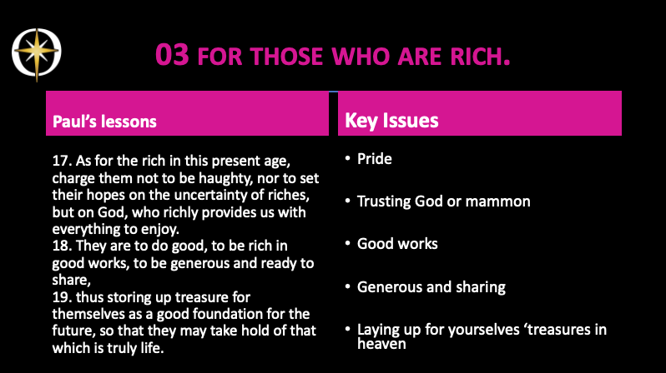

17. As for the rich in this present age, charge them not to be haughty, nor to set their hopes on the uncertainty of riches, but on God, who richly provides us with everything to enjoy.
18. They are to do good, to be rich in good works, to be generous and ready to share,
19. thus storing up treasure for themselves as a good foundation for the future, so that they may take hold of that which is truly life.

- Warn against haughtiness, pride
  - Which comes before a fall
  - Which Edges God Out = E.G.O.
  - Which worships the unholy Trinity = I, Me & Myself
- Do not trust in the uncertainty of riches
  - Money talks – but all mine says is ‘goodbye!’
  - Mammon wants to make you unstable, spiritually and psychologically
- Trust in God
  - In His provision of things to enjoy
- We are to do good
  - Help where we can– give our time, talents, and treasure to people in need
  - Give to the poor
  - Share what the Lord has given us with others.
  - We are to be a pipeline, not a holding tank.
    - Gods’ blessings should flow through us to those in need
- This all will
  - Store up for ourselves ‘treasures in heaven
  - Lay a good foundation for the future
    - Preparing us for eternal life
  - Allow us to experience ‘true life’ - which is the life of Christ in you – experiencing all God wants to do in you, through you and around you.

